Dairy Development Corporation
Janakpur milk supply scheme
DHALKEBAR, DHANUSHA

Sealed Quotation Document
for

THE PROCUREMENT OF
Construction Works of Office Buildings

Issued on:2078/02/05
Issued to: Eligible Bidder

Invitation for Quotations No(SQ No.):DDC/JMSS/SQ/077/78-08

बोलपत्र आव्हानको सूचना
(प्रथम पटक प्रकाशित मिति 2078।02।05 )
यस आयोजनाको भवन माथिल्लो तल्ला थप सम्बन्धी निर्माण कार्य सार्वजनिक खरिद ऐन, २०६३ तथा नियमावली २०६४(संशोधन सहित) र दुग्ध विकास संस्थान आर्थिक प्रशासन सम्बन्धी विनियमावली २०६६ बमोजिम गर्नुपर्ने भएकोले नेपाल सरकारबाट सम्बन्धित कार्यका लागी सम्बन्धित निकायमा दर्ता भएका फर्म, संस्था वा कम्पनीले तपसिल बमोजिमका शर्तमा रही सिलबन्दी बोलपत्र आव्हानको यो सूचना प्रकाशित गरिएको छ। सिलबन्दी बोलपत्र सम्बन्धी बिस्तृत जानकारीको लागी कार्यालय समय भित्र यस आयोजनामा सम्पर्क राख्नुहुन वा संस्थानको Website: www.ddc.gov.np मा हेर्न सक्नुहुनेछ ।
क्र.स. | बोलपत्र न. | कार्य विवरण | बोलपत्र खरिद र दाखिला गर्ने कार्यालय | बैंक तथा धरौटी खाता नं., ठेगाना | बोलपत्र दस्तुर | बिडबण्ड रकम रु. | (अनुमानित लागत रकम रु.(ओभरहेड र मु.अ.क. सहित) | बोलपत्र खरिद गर्ने, बुझाउने अन्तिम मिति र समय
१. | जे.एम.एस.एस/077-078 | तल्ला थप सम्बन्धी निर्माण कार्य | ज.दु.वि.आ.,ढल्केवर, धनुषा | सनराईज बैंक लि. बर्दिवास  च.खा.न.-02110090980014 | रु.१०००।- | रु.४९,६५६।६५ | रु.१९,८६,२६६।- | (१)खरिद मितिः२०७८।०२।१९ गते(कार्यालय समय भित्र)  (२)दर्ता मितिः२०७८।०२।२०(दिउँसो १२:०० बजे भित्र)

फोन न. 041-560195,041-560197,041-560020
Abbreviations
BD .....................................Bidding Document
BDF .................................. Bidding Forms
BDS ................................... Bid Data Sheet
BOQ ................................. Bill of Quantities
COF ................................ Contract Forms
DDC………………………………Dairy Development Corporation
DP .................................... Development Partners
ELI ................................... Eligibility
GCC ................................. General Conditions of Contract
GoN ................................. Government of Nepal
ICC .................................. International Chamber of Commerce
IFQ ….........................…… Invitation for Quotations
ITB .................................. Instructions to Bidders
JMSS……………………………Janakpur Milk Supply Scheme
NCB ............................... National Competitive Bidding
PAN ............................... Permanent Account Number
PPA ............................... Public Procurement Act
PPMO............................. Public Procurement Monitoring Office
PPR ............................... Public Procurement Regulations
SBD ............................... Standard Bidding Document
SCC ............................... Special Conditions of Contract
TS ...................................Technical Specifications
VAT................................ Value Added Tax
WRQ ............................ Works Requirement

Table of Contents

Section I. Instruction to Bidders (ITB) 2
Section II. Bid Data Sheet (BDS) 8
Section III. Eligibility Criteria 9
Section IV Bidding Forms 10
Section V Works Requirements 12
Section VI. Bill of Quantities 22
Section VII. General Conditions of Contract (GCC) 25
Section VIII. Special Conditions of Contract (SCC) 34
Section IX Contract Forms 35

Dairy Development Corporation
Janakpur Milk Supply Scheme, Dhalkebar
Invitation for SealedQuotations for the Construction of Office Buildings
Contract Identification No:DDC/JMSS/SQ/2077/078-08
Date of publication: 2078/02/05

- The Janakpur Milk Supply Scheme (JMSS) invites sealed quotations for the construction of office buildings. The estimated amount for the works is excluding VAT NRs.17,57,757.50 (Seventeen lakh fifty seven thousand seven hundred fifty seven rupees and fifty paisa).
- Eligible Bidders may obtain further information and inspect the Bidding Documents at the office of Janakpur Milk Supply Scheme, Dhalkebar, Nepal, Phone No. 041-560195,041-560197,041-560020 Website: www.ddc.gov.np, E-mail: jmssddc@gmail.com

- A complete set of Bidding Documents may be purchased from the office Janakpur Milk Supply Scheme (JMSS), Dhalkebar, Nepalby eligible Bidders on the submission of a written application upon payment of a non-refundable fee of Rs. 1000.00 till 2078/02/19 during office hours.

- Sealed bids must be submitted to Janakpur Milk Supply Scheme (JMSS), Dhalkebar, Nepal before 12:00 Noon on 2078/02/20. Bids received after this deadline will be rejected.

- The bids will be opened in the presence of Bidders' representatives who choose to attend at 2078/02/20 at 14:00 hour at Janakpur Milk Supply Scheme (JMSS), Dhalkebar. Bids must be valid for a period of 45 days after bid opening and must be accompanied by a bid security amounting to a minimum of NRs.49,656.65, which shall be valid for 30 days beyond the validity period of the bid, i.e. 75 days.

- If the last date of purchasing and /or submission falls on a government holiday, then the next working day shall be considered as the last date. In such case the validity period of the bid security shall remain the same as specified for the original last date of bid submission.

Section I. Instruction to Bidders (ITB)

1. Scope of Works | 1.1 The Employer stated in the BDS for the construction of works as detailed in attached specifications, drawings and the bill of quantities provided herein. The name of Employer, name of project and contract identification number of Contracts are provided in the BDS.
2. Eligible Bidder | 2.1 This Invitation for Bids is open to all registered contractors with eligibility criteria specified in section III Eligibility Criteria. A bidder declared blacklisted and ineligible by the GoN, Public Procurement Monitoring Office (PPMO) and/or the DP in case of DP funded project, shall be ineligible to bid for a contract during the period of time determined by the GoN, PPMO and/or the DP.  2.2 In case of a natural person or firm/institution/company which is already declared blacklisted and ineligible by the GoN, any other new or existing firm/institution/company owned partially or fully by such Natural person or Owner or Board of director of blacklisted firm/institution/company; shall not be eligible bidder.
3. One Bid per Bidder | 3.1 Each Bidder shall submit only one quotation. A Bidder who submits more than one quotation shall cause all the quotations with the Bidder’s participation to be disqualified.
4. Cost of Bidding | 4.1 The Bidder shall bear all costs associated with the preparation and submission of his bid and the Employer shall in no case be liable for those costs.
5. Site Visit | 5.1 The Bidder at his own cost, responsibility and risk may visit the site of the works and acquire all necessary information for preparing the bid and entering into a contract for construction of the works.
6. Content of Quotation Form | - 6.1 The Quotation Form comprise the documents listed below:  - Section I: Instructions to Bidders  - Section II: Bid Data Sheet  - Section III : Eligibility Criteria  - Section IV: Bidding Forms  - Section V: Works Requirements  - Section VI: Bill of Quantities  - Section VII: General Conditions of Contract (GCC)  - Section VIII: Special Conditions of Contract (SCC)  - Section IX: Contract Forms
7. Clarification | 7.1 A prospective Bidder may obtain clarification on the Quotation Form from the Employer on or before 5 days prior to the deadline for submission of quotation.
8. Language of Bid | 81. All documents relating to the bid shall be in English /Nepali.
9. Documents Comprising Bid | The bid by the Bidder shall comprise the following:  - Letter of Bid  - Eligibility Information/Document  - Bid Security and  - Priced Bill of Quantities
10. Bid Prices | 10.1 The contract shall be for the whole works described in scope of works based on the priced Bill of Quantities submitted by the Bidder. The Bidder shall fill in rates and prices for all items of the works in Nepali Rupees. Items for which no rate or price is entered shall be deemed covered by the other rates and prices in the Bill of Quantities and shall not be paid separately by the Employer.  All duties, taxes and other levies payable by the contractor under the contract shall be included in the rates, prices and total Bid Price submitted by the Bidder.
11. Bid Validity | 11.1 Bids shall remain valid for the period specified in the BDS after the bid submission deadline date prescribed by the Employer. A bid valid for a shorter period shall be rejected by the Employer as nonresponsive.
12. Bid Security | 12.1 The Bidder shall furnish as part of its bid, in original form, a bid security as specified in the BDS. In case of e-submission of bid, the Bidder shall upload scanned copy of Bid security letter at the time of electronic submission of the bid. The Bidder accepts that the scanned copy of the Bid security shall, for all purposes, be equal to the original. The details of original Bid Security and the scanned copy submitted with e-bid should be the same otherwise the bid shall be non-responsive.  12.2 The bid security shall be, at the Bidder’s option, in any of the following forms:  (a) an unconditional bank guarantee from Commercial Bank or Financial Institution eligible to issue Bank Guarantee as per prevailing Lawor;  (b) a cash deposit voucher in the Employer's Account as specified in BDS.  In the case of a bank guarantee, the bid security shall be submitted  either using the Bid Security Form included in Section III (Bidding  Forms) or in another Form acceptable to the employer. The form must include the complete name of the Bidder. The bid security shall be valid for minimum thirty (30) days beyond the original validity period of the bid  12.3 Any bid not accompanied by an enforceable and substantially compliant bid security shall be rejected by the Employer as nonresponsive. In case of e-Submission, if the scanned copy of an acceptable Bid Security letter is not uploaded with the electronic Bid then Bid shall be rejected.  12.4 The bid security shall be forfeited if:  (a) a Bidder requests for withdrawalduring the period of bid validity specified by the Bidder on the Letter of Bid, after bid submission deadline.  (b)a Bidder changes the prices or substance of the bid while providing information;  (c) a Bidder involves in fraud and corruption pursuant to clause 27;  (d) the successful Bidder fails to:  (i) furnish a performance security in accordance with clause 25 and 26;  (ii) sign the Contract in accordance within the period stipulated in Letter of Acceptance; or  (iii) accept the correction of arithmetical errors pursuant to clause 21.1
13. Format and Signing of Bids | 13.1 The bid shall be typed or written in indelible ink and shall be signed by an authorized person. Any entries or amendments including alternations, additions or corrections made shall be initialed by the same authorized person.
14. Sealing and Marking of Bids | 14.1 Bidders may submit their bids by hand copy or by electronically. When so specified in the BDS, bidders shall have the option of submitting their bids electronically. Procedures for submission, sealing and marking are as follows:  - Bidders submitting bids by hand copy: The Bidder shall submit his bid in sealed envelopes. The envelope shall be addressed to the Employer specified in the Invitation for Quotation and shall bear the name and identification number of the quotation.  - Bidders submitting Bids electronically shall follow the electronic bid submission procedure specified in the BDS
15. Deadline for Submission of Bids | 15.1 Bids shall be delivered to the Employer at the address no later than the time and date specified in BDS.
16. Late Bids | 16.1 Any bid received by the Employer after the deadline shall not be accepted and shall be returned unopened to the Bidder upon request.
17.Modification  AndWithdrawal of Bids | 17.1Bids once submitted shall not be withdrawn or modified.
18. Bid Opening | 18.1 The Employer shall open the bids in the presence of the Bidders' representatives who choose to attend at the time and in the place as specified in the BDS.The Employer shall prepare and provide minutes of the bid opening including the information disclosed to those present.
19. Process to be Confidential | 19.1 Information relating to the examination, evaluation and comparison of bids and recommendations for the award of a contract shall not be disclosed to Bidders or any other persons not officially concerned with such process until the award to the successful Bidder has been announced. Any efforts by the Bidder to influence the Employer in the bid evaluation, bid comparison or contract award decisions may result in rejection of Bidder’s bid.
20.Examination of Bids | 201. Prior to the detailed evaluation of Bids, the Employer shall determinewhether each bid (a) meets the eligibility criteria defined in Clause 2; (b) has been properly signed; (c) is accompanied by the required securities; and (d) is substantially responsive to the requirements of the Bidding documents.
21. Evaluation and Comparison of Bids | 21.1 In evaluating the Bids, the Employer shall determine for each bid the evaluated Bid Price by adjusting any corrections for errors. Bids shall be checked by the Employer for any arithmetic errors.Errors shall be corrected by the Employer as follows:  (a) only for unit price Contracts, if there is a discrepancy between the unit price and the total price that is obtained by multiplying the unit price and quantity, the unit price shall prevail and the total price shall be corrected, unless in the opinion of the Employer there is an obvious misplacement of the decimal point in the unit price, in which case the total price as quoted shall govern and the unit price shall be corrected;  (b) if there is an error in a total corresponding to the addition or subtraction of subtotals, the subtotals shall prevail and the total shall be corrected; and  (c) If there is a discrepancy between the bid price in the Summary of Bill of Quantities and the bid amount in item (c) of the Letter of Bid, the bid price in the Summary of Bill of Quantities will prevail and the bid amount in item (c) of the Letter of Bid will be corrected.  (d) if there is a discrepancy between words and figures, the amount in words shall prevail, unless the amount expressed in words is related to an arithmetic error, in which case the amount in figures shall prevail subject to (a) ,(b) and (c) above.  21.2 In case of e-submission of bid, upon notification from the employer, the bidder shall also submit the original of documents comprising the bid as per ITB 9 for verification of submitted documents for acceptance of the e-submitted bid. If a Bidder does not provide original of document of its bid by the date and time set in the Employer’s request for clarification, its bid may be rejected.  21.3 If the Bidder that submitted the lowest evaluated bid does not accept the correction of errors, its bid shall be disqualified and its bid security shall be forfeited.  21.4 In Case, a corruption case is being filed to Court against the Natural Person or Board of Director of the firm/institution /company or any partner of JV, such Natural Person or Board of Director of the firm/institution /company or any partner of JV such bidder’s bid shall be excluded from the evaluation, if public entity receives instruction from Government of Nepal.
22. Award of Contract | 22.1 The Employer shall decide the award of the contract to the Bidder whose bid is within the approved estimate and who has offered the lowest evaluated Bid Price within bid validity period provided that such Bidder has been determined to be eligible in accordance with the provisions of Clauses 2.  22.2 if the bid for an Unit Rate Contract, which results in the lowest Evaluated Bid Price is seriously unbalanced or front loadedor extremely low in the opinion of the Employer, the Employer may require the Bidder to produce detailed price analysis for any or all items of the Bill of Quantities, to demonstrate the internal consistency of those prices with the construction methods and schedule proposed. After evaluation of the price analysis, taking into consideration the schedule of estimated Contract payments, the Employer may require that the amount of the performance security be increased at the expense of the Bidder as mentioned in BDS to protect the Employer against financial loss in the event of default of the successful Bidder under the Contract or may consider the bid as non-responsive.
23. Employer's Right to Accept any Bid and to Reject any or all Bids | 23.1 The Employer reserves the right to accept or reject any bid or to cancel the bidding process and reject all bids, at any time prior to the award of the contract, without assigning any reasons whatsoever and without thereby incurring any liability to the affected Bidder or Bidders.
24. Notification of Award and Signing of Agreement | 24.1 The Bidder whose bid is accepted and all other participating bidders shall be notified of the award by the Employer.  24.2 The notification (hereafter called the “Letter of Acceptance”) to the successful Bidder shall state the sum that the Employer shall pay the Bidder in consideration of the execution, completion, and maintenance of the works as described by the contract. Within 7 days of receipt of the Letter of Acceptance, the successful Bidder shall deliver the Performance Security pursuant Clause 25and sign the Agreement.  24.3 Inability of the Bidder to make an Agreement within the above stated period shall result in cancellation of the Contract Award and forfeiture of the Bidder’s Bid Security, upon which the Contract shall then be awarded to the next successive successful Bidder.
25.Performance Security | 251. Within seven (7) days of the receipt of Letter of Acceptance from the Employer, the successful Bidder shall furnish the performance security as under mentioned from Commercial Bank or Financial Institution eligible to issue Bank Guarantee as per prevailing Law in Nepalin accordance with the conditions of Contract using Sample Form for the Performance Security included in Section IX (Contract Forms), or another form acceptable to the Employer.  i) If bid price of the bidder selected for acceptance is up to 15 (fifteen) percent below the approved cost estimate, the performance security amount shall be 5 (five) percent of the bid price.  ii) For the bid price of the bidder selected for acceptance is more than 15 (fifteen) percent below of the cost estimate, the performance security amount shall be determined as follows:  Performance Security Amount =  [(0.85 x Cost Estimate – Bid Price) x 0.5] + 5%of Bid Price.  The Bid Price and Cost Estimate shall be inclusive of Value Added Tax.
26.Additional Securities | 26.1 The Bidder may be required to provide additional Performance Security if the Employer determines that the rate quoted by the Bidder in the Bill of Quantities, front loaded or unbalanced.In such case, the Employer shall instruct the Bidder to provide additional 8% security for signing of the Contract Agreement. Bidder’s failure to do provide additional security shall result in forfeiture of the Bid Security and award of the Contract to the next lowest evaluated Bidder.
27.Corrupt or Fraudulent Practices | 27.1 The Employer shall reject a bid for award if it determines that the Bidder recommended for award of contract has engaged in corrupt or fraudulent practices in competing for the contract in question.
28.Conduct of Bidders | 28.1The Bidder shall be responsible to fulfill his obligations as per the requirement of the Contract Agreement, Bidding documents, GoN’s Procurement Act and Regulations.  28.2 The Bidder shall not carry out or cause to carry out the following acts with an intention to influence the implementation of the procurement process or the procurement agreement :  - give or propose improper inducement directly or indirectly,  - distortion or misrepresentation of facts  - engaging or being involved in corrupt or fraudulent practice  - interference in participation of other prospective bidders.  - coercion or threatening directly or indirectly to cause harm to the person or the property of any person to be involved in the procurement proceedings,  - collusive practice among bidders before or after submission of bids for distribution of works among bidders or fixing artificial/uncompetitive bid price with an intention to deprive the Employer the benefit of open competitive bid price..  - contacting the Employer with an intention to influence the Employer with regards to the bid or interference of any kind in examination and evaluation of the bids during the period after opening of bids up to the notification of award of contract
29.Blacklisting Bidder | 29.1 Without prejudice to any other right of the Employer under this Contract, GoN, Public Procurement Monitoring Officemay blacklist a bidder for his conduct up to three years on the following grounds and seriousness of the act committed by the bidder:  - if it is proved that the bidder committed acts pursuant to the Sub-Clause 28.2,  - if it is proved later that the bidder/contractor had committed substantial defect in implementation of the contract or had not substantially fulfilled his obligations under the contract or the completed work is not of the specified quality as per the contract ,  - if convicted by a court of law in a criminal offence which disqualifies the bidder from participating in the contract.  - if it is proved that the contract agreement signed by the bidder was based on false or misrepresentation of bidder’s qualification information,  29.2 A firm declared blacklisted and ineligible by the GON shall be ineligible to bid for a contract during the period of time determined by the PPMO.
30. Provision of PPA and PPR | If any provision of this document is inconsistent with Public Procurement Act (PPA), 2063 or Public Procurement Regulations (PPR), 2064, the provision of this documents shall be void to the extent of such inconsistency and the provision of PPA and PPR shall prevail.

SECTION - II
Bid Data Sheet
ITB 1 | The scope of work is: ConstructionWorks of Office Buildings  The number of the Invitation for Bids is : DDC/JMSS/SQ/2077/078-08  The Employer is: Janakpur Milk Supply Scheme, Dhalkebar.
ITB 11 | The bid validity period shall be: 45(Forty Five) Days.
ITB 12.1 | The Bidder shall furnish a bid security, from Commercial Bank or Financial Institution eligible to issue Bank Guarantee as per prevailing Law with a minimum of NRs.49,656.65 which shall be valid for 30 days beyond the validity period of the bid.
ITB 12.2 (b) | Cash Deposit Account for Bid Security:  Current Account No. : 02110090980014 Bank Name: Sunrise Bank  Bank Address: Bardiwas Name of Office : Janakpur Milk Supply Scheme
ITB 14.1 | Bidders “shall not” have the option of submitting their bids electronically.
ITB 15 | The deadline for bid submission is: Janakpur Milk Supply Scheme  Address: Dhalkebar  Date:2078/02/20  Time : 12:00 Noon
ITB 18 | The bid opening shall take place at :  Address :Janakpur Milk Supply Scheme,Dhalkebar  Date:2078/02/20  Time : 14:00 hour

Section- III: Eligibility Criteria

Eligibility Information

Eligibility Requirements:
All Bidders shall submit following documents as pre- requisites for eligibility:
- Firm/Company Registration Certificate
- Business Registration Certificate
- PAN/VAT Registration Certificate
- Tax Clearance Certificate for the F/Y 2076/077
- Power of Attorney for Bid Signatory
- Letter of Bid
- A written declaration made by the bidder, with a statement that s/he is not ineligible to participate in the procurement proceedings; has no conflict of interest in the proposed procurement proceedings, and has not been punished for a profession or business related offenses.

Section- IV: Bidding Forms
Letter of Bid
The Bidder must accomplish the Letter of Bid in its letterhead clearly showing the Bidder’s complete name and address.
Date: .........................................................
Name of the contract: ConstructionWorks of Office Buildings
Invitation for Bid No.: DDC/JMSS/SQ/2077/078-…….
To: ……………………………………………………………………………………………………….....
We, the undersigned, declare that:
- We have examined and have no reservations to the Bidding Documents.
- We offer to execute in conformity with the Bidding Documents the following Works:
- The total price of our Bid, excluding any discounts offered in item (d) below is:…………………………
- The discounts offered and the methodology for their applicationare:………………………………………
- Our bid shall be valid for a period of 45 days from thedate fixed for the bid submission deadline in accordance with the Bidding Documents, and it shall remain binding upon us and may be accepted at any time before the expiration of that period;
- If our bid is accepted, we commit to obtain a performance security in accordance with the Bidding Document;
- We understand that this bid, together with your written acceptance thereof included in your notification of award, shall constitute a binding contract between us, until a formal contract is prepared and executed;
- We declare that, we have not been black listed and no conflict of interest in the proposed procurement proceedings and we have not been punished for an offense relating to the concerned profession or business.
- We understand that you are not bound to accept the lowest evaluated bid or any other bid that you may receive; and
- If awarded the contract, the person named below shall act as Contractor’s Representative:
- We agree to permit the Employer/DP or its representative to inspect our accounts and records and other documents relating to the bid submission and to have them audited by auditors appointed by the Employer.

Name: .................................................................................................

In the capacity of .............................................................................
Signed …………………………………………………………...

Duly authorized to sign the Bid for and on behalf of …………

Date …………………………………………………………....
Bid Security
Bank Guarantee

Bank’s Name, and Address of Issuing Branch or Office
(On Letter head of the Commercial bank or any Financial Institution eligible to issue Bank Guarantee as per prevailing Law)

Beneficiary: .............................. name and address of Employer……………………………….
Date:………………...
Bid Security No.:.........................................................................

We have been informed that . …………. .[insert name of the Bidder] (Hereinafter called “the Bidder”)
intends to submit its bid (hereinafter called “the Bid”) to you for the execution of …………... name of
Contract .…………… under Invitation for Quotations No. ……………… (“the IFQ”).

Furthermore, we understand that, according to your conditions, bids must be supported by a bid guarantee.

At the request of the Bidder, we…………………. . name of Bank. ………………..hereby irrevocably undertake to pay you any sum or sums not exceeding in total an amount of. . ………...amount in figures ………………………. (. ………….. .amount in words ……………….) upon receipt by us of your first demand in writing accompanied by a written statement stating that the Bidder is in breach of its obligation(s) under the bid conditions, because the Bidder:

(a) does not accept the correction of errors in accordance with the Instructions to Bidders
(hereinafter “the ITB”); or
(b) having been notified of the acceptance of its Bid by the Employer during the period of bid validity, (i) fails or refuses to execute the Contract Agreement, or (ii) fails or refuses to furnish the performance security, in accordance with the ITB.
(c) is involved in fraud and corruption in accordance with the ITB

This guarantee will remain in force up to and including the date ………number…………days after the deadline for submission of Bids as such deadline is stated in the instructions to Bidders or as it may be extended by the Employer, notice of which extension(s) to the Bank is hereby waived. Any demand in respect of this guarantee should reach the Bank not letter than the above date.

This Bank guarantee shall not be withdrawn or released merely upon return of the original guarantee by the Bidder unless notified by you for the release of the guarantee.

This guarantee is subject to the Uniform Rules for Demand Guarantees, ICC Publication No. 758.
. . .Bank’s seal and authorized signature(s) . . .
Note:
The bid security of ………..……………. has been counter guaranteed by the Bank ……..………...on
…………... ...……..………. (Applicable for Bid Security of Foreign Banks).
SECTION - V
Works Requirements

Specification for floor extension of Janakpur Milk Supply Scheme, Dhalkebar, Dhanusha

1. Water

Water should be clean and free from oil, waste acid or other organic matter. The contractor shall make his own arrangement for supply of water.

2. Fine Aggregate

Sand shall be clean river or pit sands of approved quality and free from salt, earth, dust, or other impurities, sand containing more then 6 percent clay dust and silt shall be washed with clean water.

3. Coarse Aggregate:

Coarse aggregate shall be crushed rock and free from vegetable matter, clay, dust. if required, aggregate shall be washed in clean water to achieve the specified freedom from contamination and to keep dust free.

4. Brick:

Brick should be first class good quality & approved by the engineer. It should be free from girt, line, Iron, salts. It should well-burnt copper colored, hard, square with sharp edges & shall give ringing sound when struck with a mallet. It shall be of uniform size and no brick after 24 hours immersion in water it shall absorb water more than 15% of its weight.

5. Cement:

Ordinary Portland cement shall conform to IS 269-1989. It should be fine. It's chemical composition, consistency, setting time must be according as IS. It should be packed in gunny bags or waterproof paper and should be free from lumps. Generally Nepal product cement should be used.

6. Brick masonry work:

All the brick shall be clean with water and immersed in water for a period of 12 hrs. Immediately before use. Brick shall be well bounded throughout the whole work and well bedded, All joints should be of uniform thickness of 10 mm and all courses shall be in true level. Brickworks should be vertical and true to line and dimension level. Vertical joints of consecutive coarse shall not come directly over one another. No damaged brick shall be used. Brickwork must be kept wet for at least 7 days. Brick work shall be carried out not more than 1 m height at a time. When one part of the wall has to be delayed stepping shall be left at an angle of 45°, All joints should be raked and faces of wall cleaned at the end of each days works. The brickwork shall be protected from the effects of sun, rain, frost etc during the construction.

7. Reinforced cement concrete R.C.C.

(I) Steel:

Steel bars shall be of mild steel deformed bar and free from corrosion, loose rust, oil, grease paint etc. Bar shall be hooked and bent accurately and placed in position as per drawing and instruction and bound together tight with 20 S.W.G. annealed wire at their points of intersection. Joint in the bar should be avoided as far as possible, when joints have to be made an overlap of 40 times dia. of the bar shall be given with proper hooks at end and joints should be staggered. While concreting, steel bars shall be given side and bottom covers of minimum 1" thick concrete by placing stone peace underneath of steel.

(II) Centering/Shuttering:

Centering and shuttering shall be made with timber or steel plate close and tight to prevent leakage of mortar with necessary props, bracings and wedges sufficiently strong and stable to support the concrete and works. The shutter shall have smooth and even surface and its joint shall be close tight and shall not permit leakage of cement mortar, if required; the joints shall be lined with craft paper or other approved material. Inner face of shuttering shall be applied with a wash of mould oil or soap solution or other approved material to prevent adherence of the concrete. The formwork shall be plane or as per requirements. It should be as light as possible. Formwork shall not be removed before 48 hours for the side of columns, beams and 18 days for the underside of beams and slab. The designed live load shall not be allowed on any structure before 23 days.

(III) Concreting :

In given ratio, first of all cement and sand shall be mixed dry thoroughly and then this dry mix shall be placed over a stack of measured stone aggregate and the whole mixed dry turning at least 3 times to have uniform mix. Water shall then be added slowly and gradually while being mixed to the required quantity to give a plastic mix of the required work ability and water cement ratio. The whole shall be mixed thoroughly turning at least three times to give a uniform concrete. Then concrete shall be laid continuously in layer not exceeding 15 cm and compacted by pining with rods and tamping with wooden tampers or with mechanical vibrating machine until a dense concrete is obtained.
Over vibration which will separate coarse aggregate from concrete should be avoided. The time between mixing and placing of concrete shall not exceed 20 minutes, Concrete shall be laid continuously, if laying is suspend for rest of the following day the end shall be sloped at an angle of 30 and made rough for future jointing, when the work is resumed, the previous sloped position shall be roughened, cleaned and watered and a coat of neat cement shall be applied and the fresh concrete shall be laid. During laying and compacting of concrete, the reinforcing bars should not move from their position. After about 24 hours of laying when concrete has begun to harden it shall be kept damp by covering with wet gunny bag or wet sand continuously for 28 days.

8. Plastering:

The materials of mortar shall first dry mixed by measuring with boxes to have the required proportion (as specified) and then water added slowly and gradually and mixed thoroughly. Then the surface watered and cleaned of all dust, dirt. Concrete surface shall be properly hacked to get adequate key. The mixtures shall be applied evenly with force on the surface. The plaster shall be of thickness as specified. The surface shall be finished at once by being rubbed over with trowel surface till cement appears on the surface. All corners, angles and junction shall be truly vertical and horizontal. The finished plaster shall then be left to cure for 10 days.

9. Punning:

Before applying cement/sand punning the first coat should be swept clean of any dust or loose particles. The average thickness of punning shall not be less than 3 mm. The coat shall be finished by rubbing with a steel trowel and any depression shall be filled in and rubbed to shining surface. All punning surface shall be finished; smooth, even, and truly level as per instruction. The punning surface shall be kept wet for 7 days.

10. C.G.I Sheet roofing:

C.G.I. sheet shall be as specified gauge. It shall be free from rust, cracks, split edges, twists etc. The sheet shall be laid on M.S. purlins with an end over lap of 23 cm and side overlap of two corrugations. It shall be fixed to the purlins with screws/ bitumen washer. There shall be a minimum of three nos screws placed at the ridge of corrugations each sheet on every purlin and their spacing shall not exceed 30 cm. Roof shall be covered with plain G.I. sheets. The ridges shall be of 60 cm overall width plain G.I. sheets properly bent to shape.

11. Steel roof truss:

The roof truss, purlin shall be made of medium duty M.S. pipes (black pipe) & shall be fabricated and installed as per drawing & instruction of engineer. The bearing plates of the truss shall be bolted to the column by anchor bolts with hinged nuts and washer, steel shall be new clean straight and free from rust. The contractor shall be solely responsible for the accuracy of fabrication. It shall supply all bolts, nuts, washers, plates, angles etc for connection. All the rust & dirt of surface shall be removed by scrapping & grinding & then the surface shall be painted with two coat of red oxide.

12. Enamel Painting:

Painting material shall be only ready-made type in sealed tins and approved by engineer. Color also shall be approved by engineer. If thinner is required pure turpentine may be added to the required extent. The surface shall be perfectly smooth by rubbing with sand paper of different grades. All holes and open joints shall be filled with strong putty. In steel, all ruts and scales shall be perfectly removed by scraping and brushing. Then one priming coat and then two coats of paints shall be applied. The paint shall be applied with brushes evenly and smoothly by crossing and no brush marks should be visible. Each coat shall be perfectly dry before the next is applied.

13. Weather coat / Emulsion Painting :

Painting material shall be only ready mixed type on sealed tins in approved color and quality – paint shall be mixed and applied strictly in accordance with the manufacture's instruction and with the approval of the engineer. Before painting is commenced on the surface, all dirt and foreign matter shall be completely removed. The surface shall be sprayed with water several times with a few minute interval to allow the moisture to soak into the surface. Then the paints solution shall be applied on the surface with hairbrushes in a number of coats to get uniform finish. Required number of coats as specified shall be given similarly to get a uniform color
14. Aluminium Door and window:
These shall be fabricated from 15 micron natural or color anodized Aluminium profiles conforming to IS: 733-1983. The glazing glass shall be clear IAG float glass or equivalent without any distortion. The window shall be made out of extruded aluminium section (Al. Mg. Si.) and shall conform to IS – 63400, AA-6063 unless otherwise directed. Aluminium sections shall be anodized and the anodic film shall be 12-15 microns. The colours shall be as directed. The 2-3 tracks on outer frame of standard size otherwise directed shall be fixed in the position by using heavy duty plastic grips with necessary plugs and fillers. All the sliding shutters shall be provided with two ball bearing rollers and ratting pieces/guides one each at the top and bottom, weather strips all around. Openable window shall be double weather stripped, one strip shall be provided in outer frame and outer shall be in the shutter frame. The hinges or stay hinges of openable window shall be strong. Pin of the hinges shall be of non-corroding materials, preferably nylon/steel. All the joints shall be mechanically fixed. All the window shutter shall be provided with special locking arrangement. Glass shall be fixed in the shutter by means of rubber gaskets. Construction Procedures The sliding window frames are of two-track design and the shutters are to be jointed by special cleats for extra strength. Rollers mounted on ball bearings are to be fitted to obtain smooth operation. The sliding shutters shall have provisions for grooves for weather strips to exclude wind, water or dust ingress. The shutters are glazed with 4mm thick approved quality and clear transparent glass using gaskets of ethylene- propylene or PVC (EPDM/ PVC). The doorframe shall be made of aluminium extrusion as per design. The ventilator frames with fixed glass shall be of same dimension as the sliding two-track frame. The frames and shutters are to be fabricated by using the crimping method of corner jointing. Corners of frames are to be miter cut on high speed TCT saw machines to give burr free corners.. The frames shall be firmly secured to the walls in line and level.Only aluminium screws shall be used for joining and no welding will be allowed. The joint between the frame and the plaster on walls, sill and lintel beam shall be filled with silicon sealant. The aluminium windows/ ventilators/ doors shall be free from scratches and other visible defects. The frames are fixed to the wall with plastic grips and steel screws of suitable color. Standard Sizes, Tolerances The sizes for doors, windows and ventilators frames shall not vary by more than ±1.5 mm.. All panels shall have properly squared corners and straight edges. Measurement of works will be made in m2 of works as specified.

Drawings
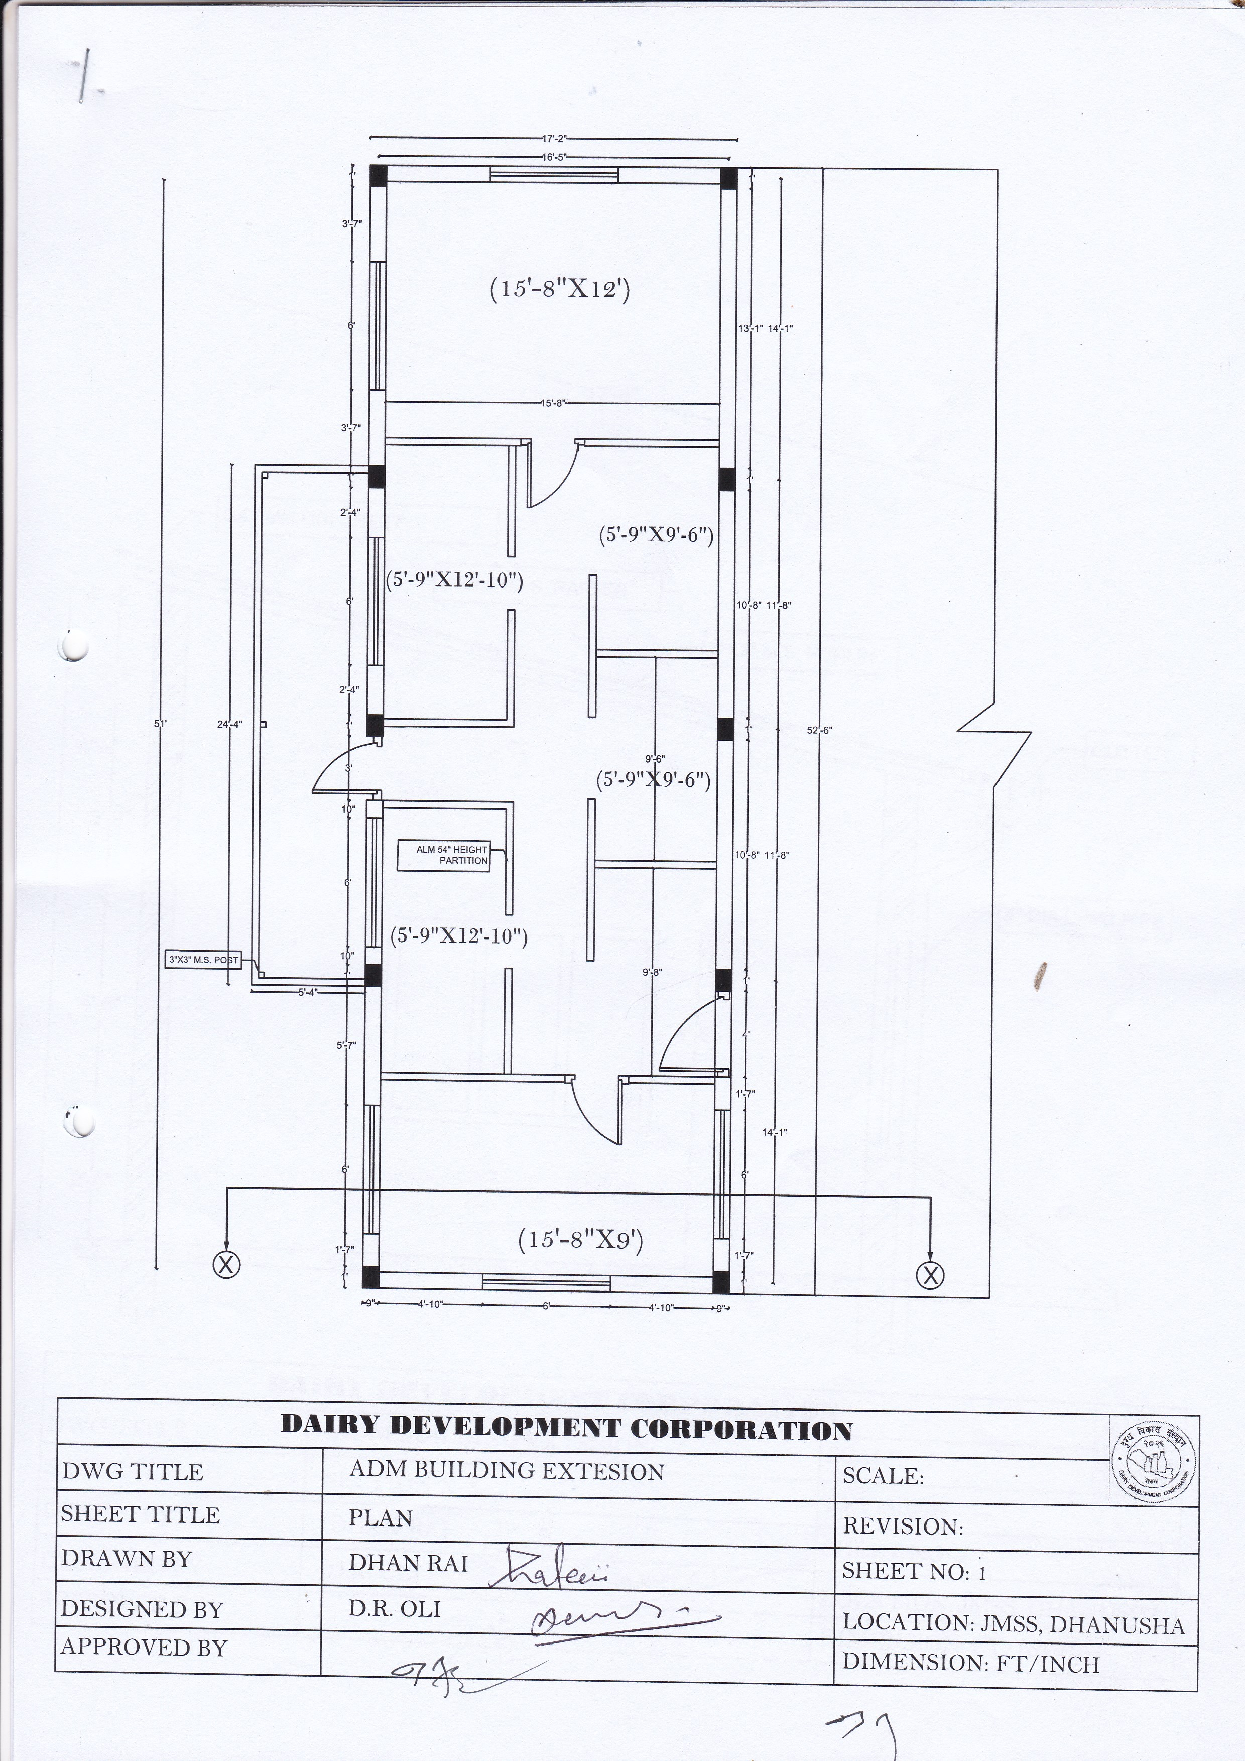

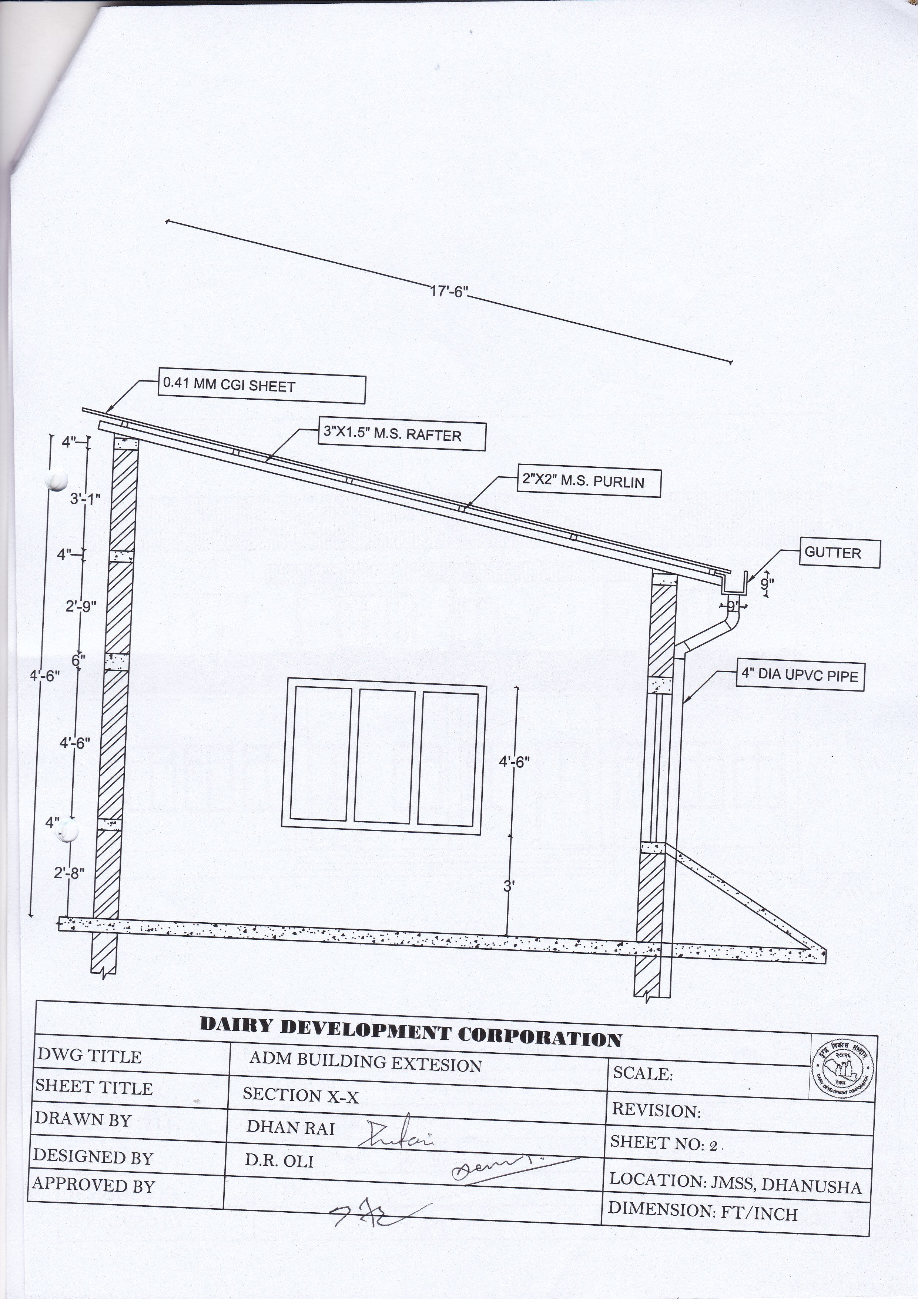

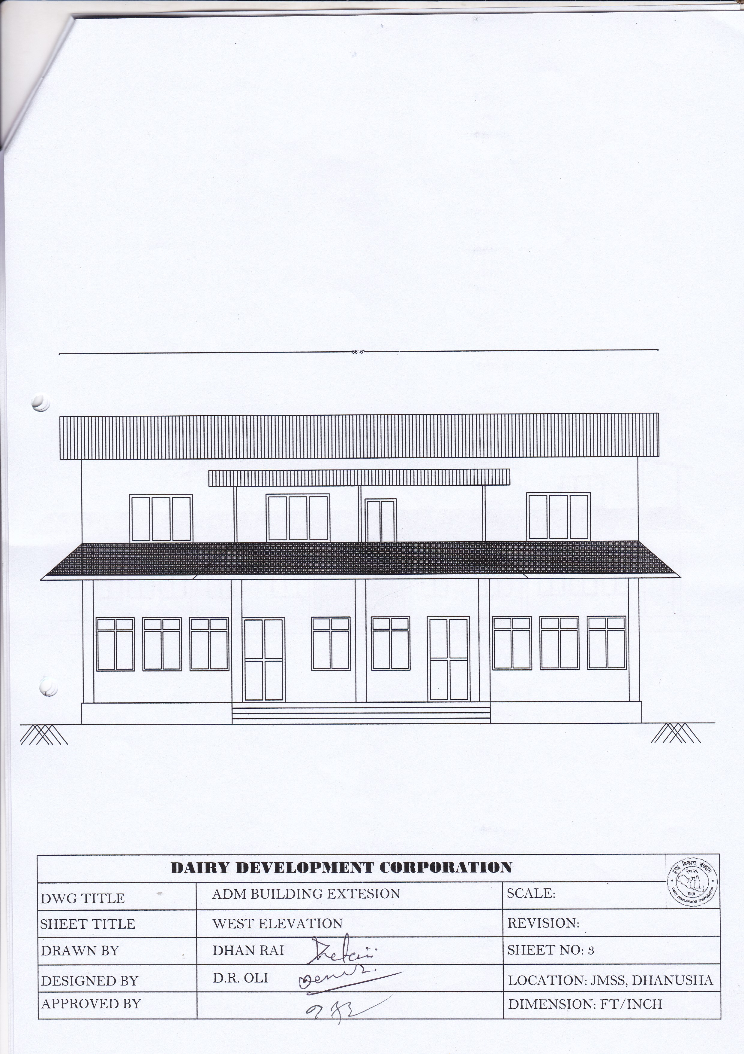

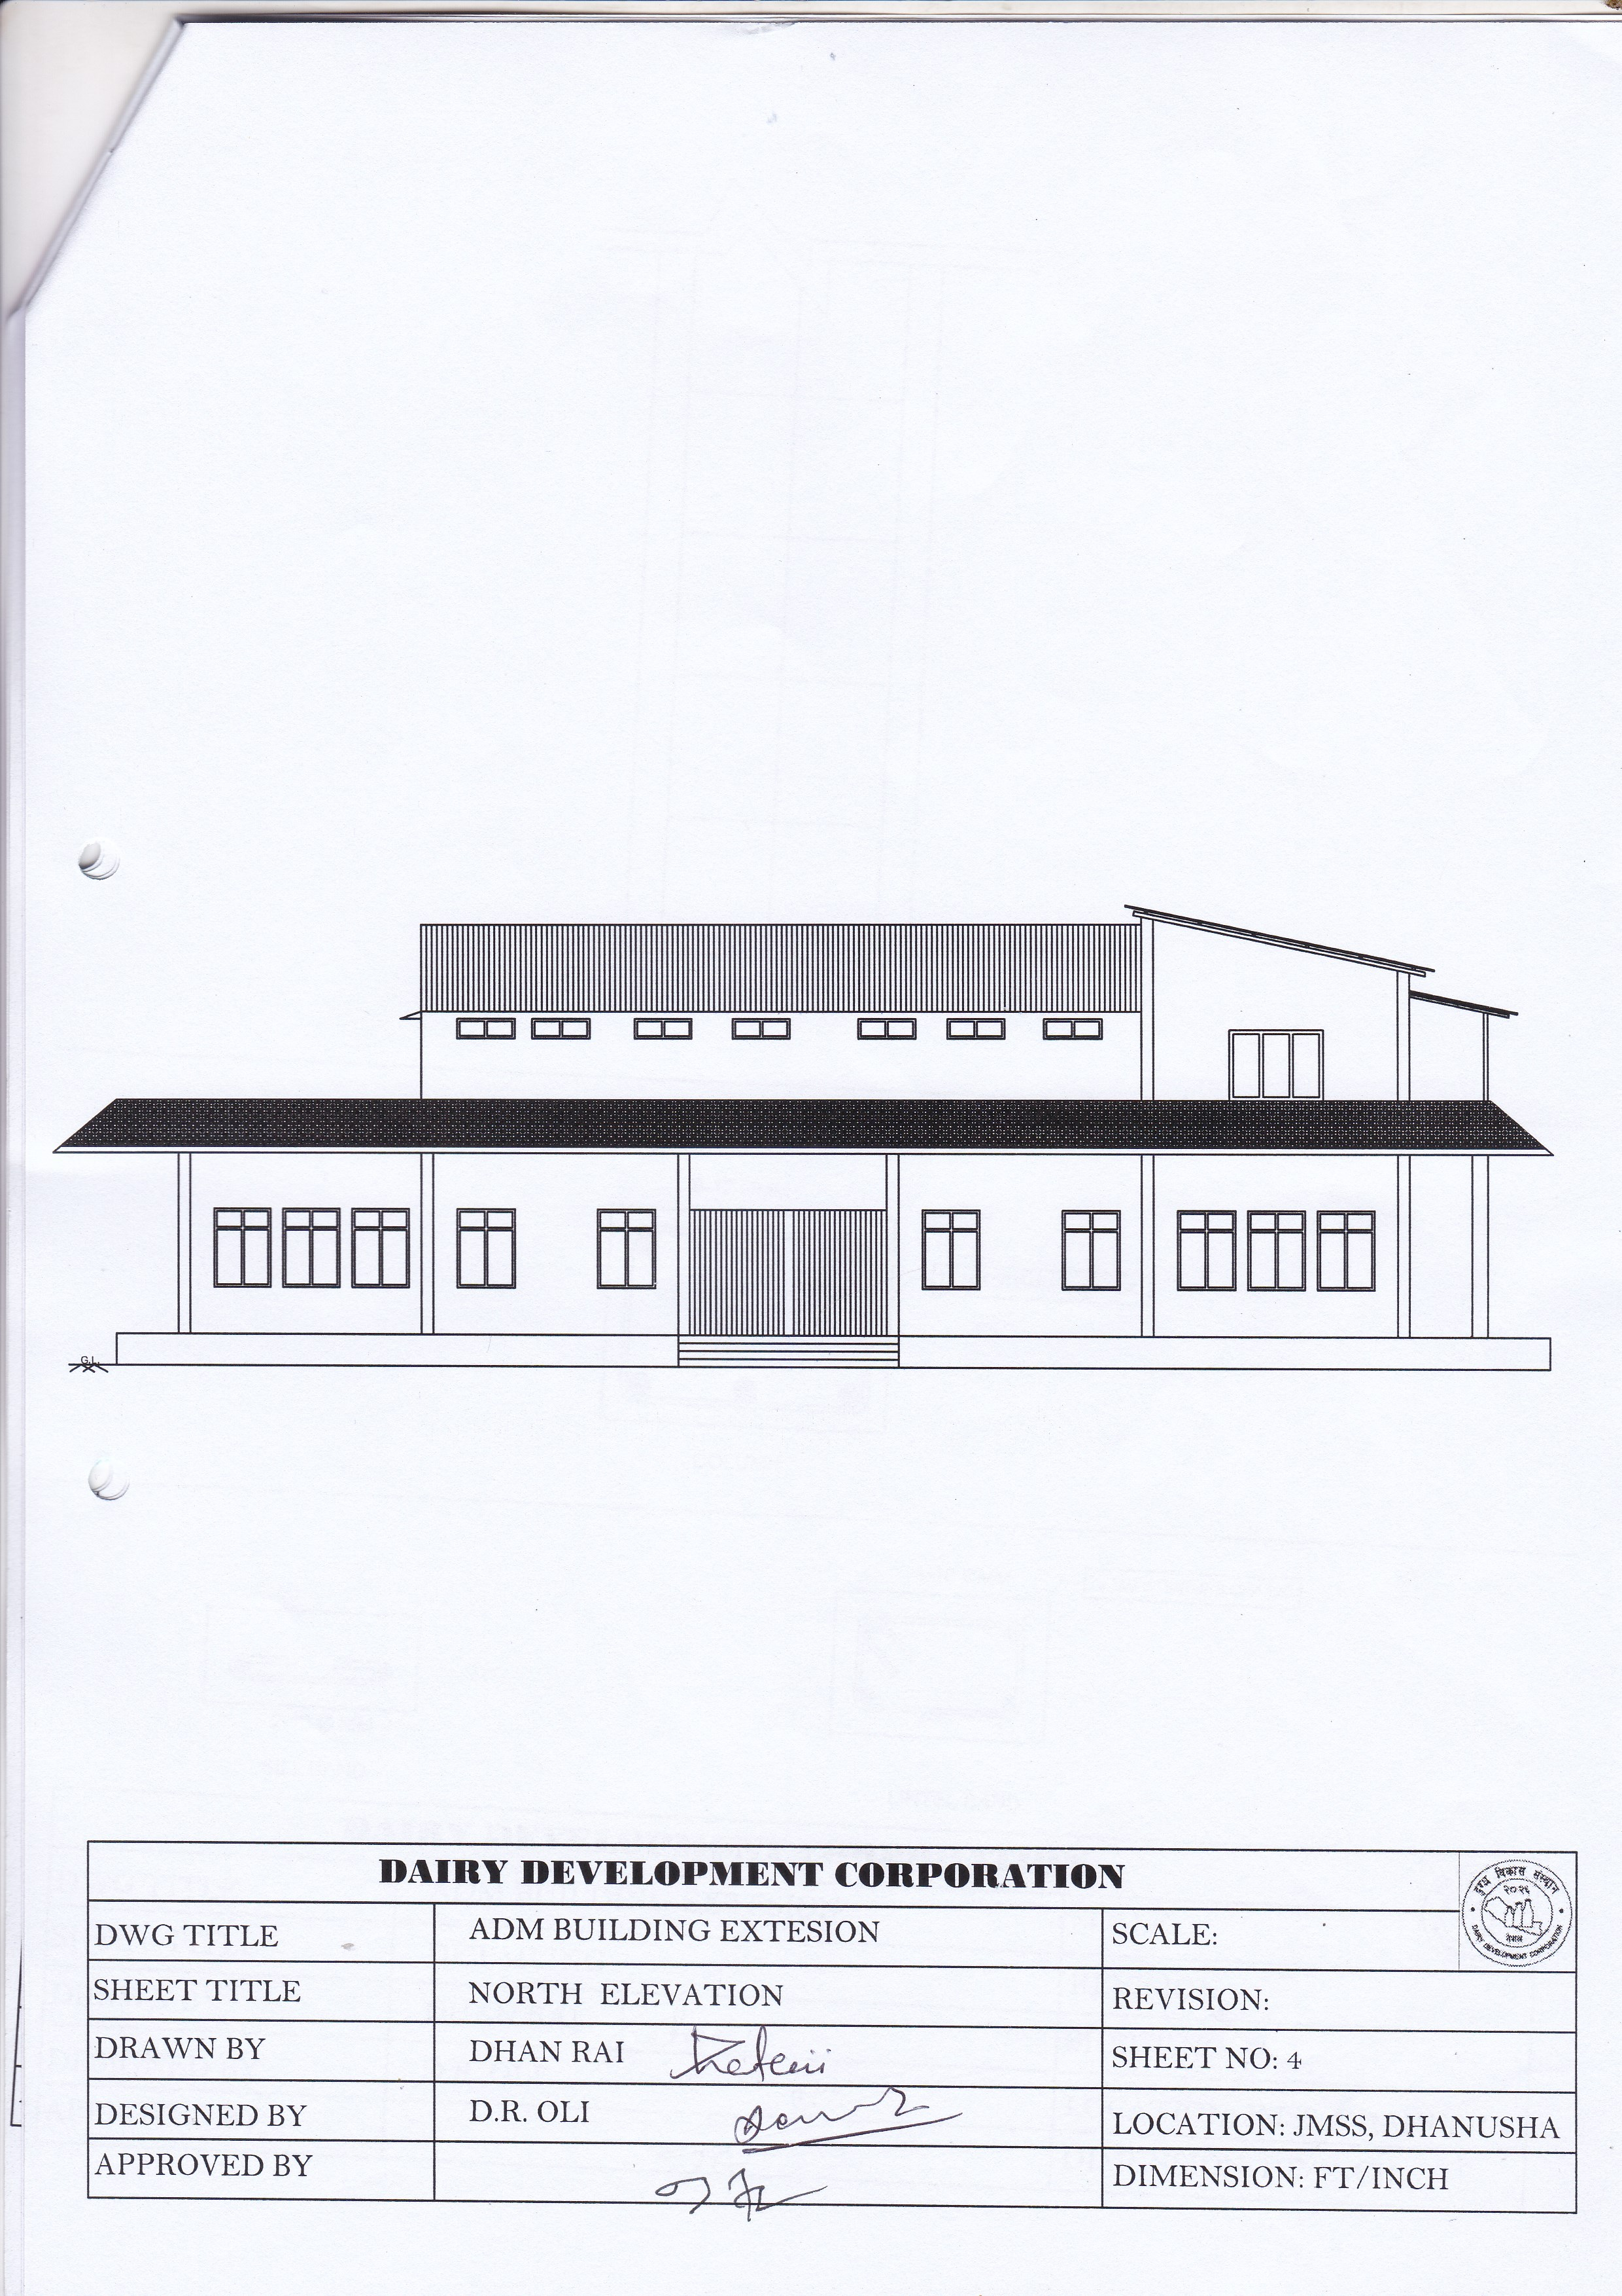

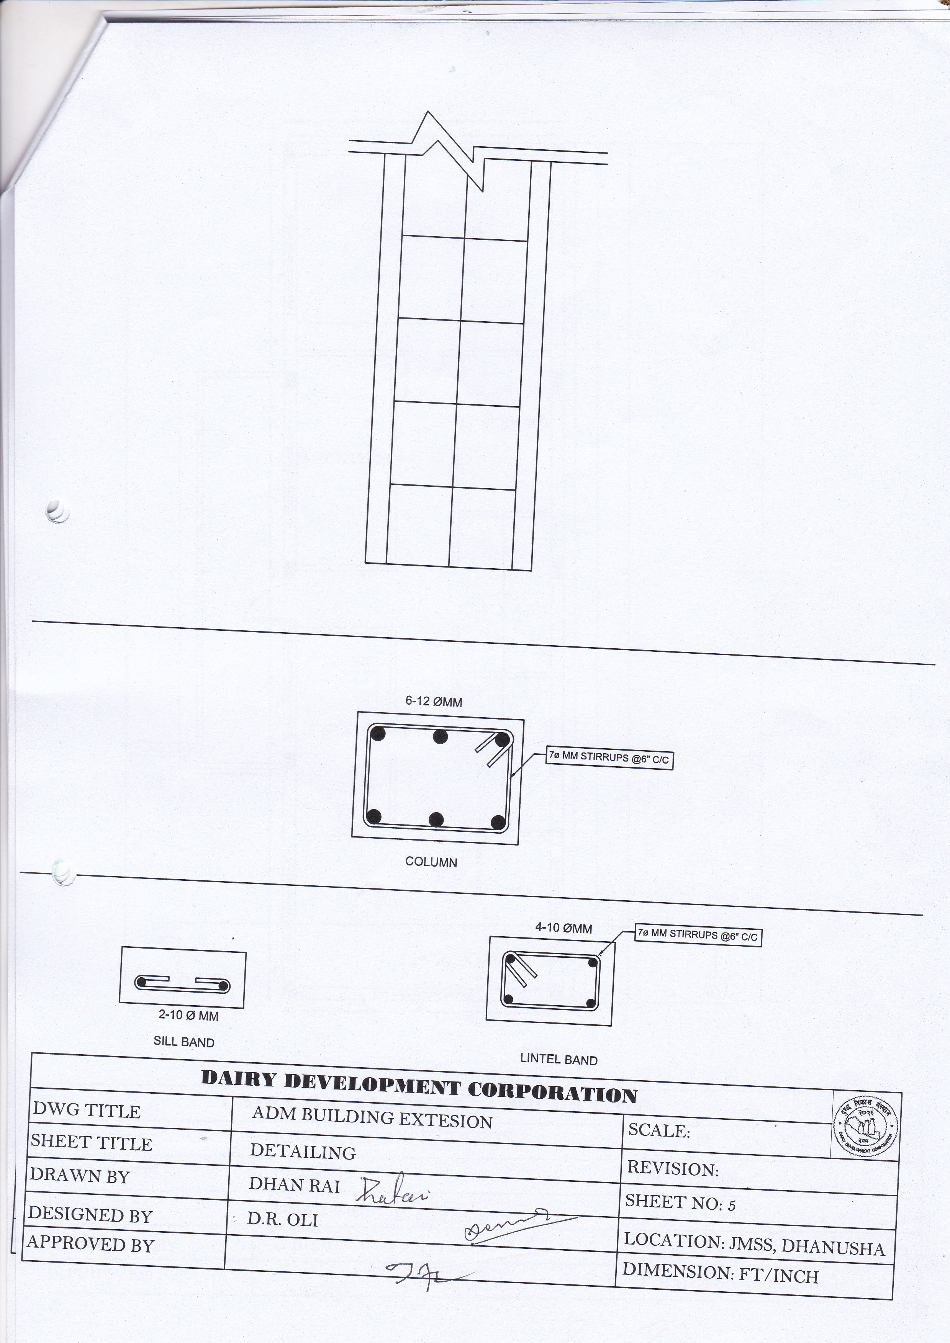

SECTION - VI

Bill of Quantities

Name of Bidder:……………….. Contract Identification Number: DDC/JMSS/SQ/2077/078-08
S.  N. | Description of Works | Qty. | Unit | Rate/unit |  | Amount
 |  |  |  | In figure | In words
1. | First class chimney made brick masonry in 1:4 cement sand mortar in perfect line level and finishing with providing material as per instruction | 909.31 | cuft
2 | 1:2:4 PCC work with ordinary portland cement ,coarse sand crushed aggregate including mixing, laying and compacting in actual line and level | 185.93 | cuft
3 | Form work for RCC work with actual Centering and shuttering as per approved material | 731.80 | sqft
4 | M.S. reinforcement bar with cleaning, cutting, straighting, bending, positioning as per instruction. | 638.33 | Kg
5 | Providing and fixing in position 14 gauge M.S. tubular pipes for roofing components(purlin, truss) with two coat red oxide paint as per drawing and instruction | 674.66 | Kg
6 | Providing and roof covering with 0.41 mm colored CGI sheet with necessary screw and bitumen washers as per specification, drawing and instruction of engineer. | 1450.35 | Sqft
7 | 1/2" thick 1:4 cement/ sand plaster on wall face with curing | 2901.75 | Sqft
8 | Providing and fixing aluminium sliding window of section of 90 series 1.2 mm thick fitted with 5 mm clear glass with ss flymesh shutter as per drawing, specification and instruction | 216.00 | Sqft
9 | Providing and fixing single panel casement door of secton (102x45x1.5) mm fitted with 5 mm clear glass and 9 mm ACP board | 97.50 | Sqft
10 | Aluminium partation of 5mm thick glass and 9 mm thick laminated board of section (102x45x1.5) mm | 274.20 | Sqft
11 | Aluminium partation of 5mm thick glass and 9 mm thick laminated board of section (64x38x1.1) mm | 292.50 | Sqft
12 | Providing and fixing 12. 5 mm thai gypsum board false ceilling in actual line and level as specification | 798.66 | Sqft
13 | Dismental for existing RCC column | 18.75 | cuft
14 | Dismental for existing brick wall | 20.00 | cuft
15 | Dismental forexisting roofing componants | 1.00 | L/S
16 | Dismental for existing floor layer(sreeding and punning) if need | 1030.58 | Sqft
17 | Laying of 1" thick C/S screding (1:6) in actual line and level | 1030.579 | Sqft
18 | laying of 1/8" thick C/S punning (1:1) in actual line and level | 1066.579 | Sqft
19 | Providing and fixing M.S. grill of square rod for window/doors | 290.00 | Kg
20 | Providing and applying of 2 coat apex weather coat on wall with primer as per specification. | 4464.41 | Sqft
21 | Providing and fixing 22 gauge colored GI plain sheet gutter of sixe 7"x7" with necessary fittings | 84.66
22 | Providing and fixing 4" dia upvc pipe (6 kg /cm2) as per actual line level and instruction | 75.00 | RF
23 | Providing and applying of 2 coat enamel paint on matel/wooden surface as per instruction | 286.00 | Sqft
24 | Site clerance after finished the construction work | 1.00 | L/S
 | Sub Total
 | Total
 | 13% VAT
 | Grand Total

Name:…………………………………
In the capacity of:………………………
Signed:…………………………..
Duly authorized to:……………………..
Sign the Bid for and on behalf of:……………………..
Date:…………………………
Seal:……………………………..

Section VII. General Conditions of Contract (GCC)

1. General Provisions
1.1 Definitions | In the Contract as defined below, the words and expressions defined shall have the following meanings assigned to them, except where the context requires otherwise:
The Contract | 1.1.1 “Contract” means the Agreement signed between the Employer and the contractor and the other documents listed in the Special Conditions of Contract (SCC).  - “Specification” means the document as listed in the SCC, and any variation to such document.  - “Drawings” means the Employer’s drawings of the Works as listed in the SCC, and any variation to such drawings.  - “Bill of Quantities” means the priced and completed bill of quantities forming part of the Tender.  - “Bid or Quotation” means the contractor’s priced offer to the Employer for the execution and completion of the Works and the remedying of any defects therein in accordance with the provisions of the Contract, as accepted by the Letter of Acceptance.  - “Letter of Acceptance” means the formal acceptance by the Employer of the bid or Tender.
Persons | - “Employer” means the person named in the Agreement and the legal successors in title to this person, but not (except with the consent of the contractor) any assignee.  - “Contractor” means the person named in the Agreement and the legal successors in title to this person, but not (except with the consent of the Employer) any assignee.  - “Party” means either Employer or the contractor.
Date, Times and Periods | - "Commencement Date" means the date stated in the SCC after the date the Agreement comes into effect or any other date agreed between the Parties.  - "Day" means a calendar day.  - "Time for Completion" means the time for completing the Works as stated in the SCC (or as extended under Sub-Clause 6.3), calculated from the Commencement Date.
Money and Payments | - "Cost" means all expenditure properly incurred (or to be incurred) by the contractor, whether on or off the Site, including overheads and similar charges, but does not include profit.  - “Contract Price” means the sum stated in the Letter of Acceptance as payable to the contractorand adjusted withany Variation Orders and Other Adjustments uponcompletion of the works and the remedying of any defects therein in accordance with the provisions of the Contract.  - “Retention Money” means the aggregate of all monies retained by the Employer pursuant to Sub-Clause 10.3
Other Definitions | - “Contractor's Equipment" means all apparatus, machinery, vehicles, facilities and other things required for the execution of the Works but does not include Materials or Plant.  - "Country" means Nepal.  - "Employer's Liabilities" means those matters listed in Sub-Clause 5.1.  - "Materials" means things of all kinds (other than Plant) intended to form or forming part of the permanent work.  - "Plant" means the machinery and apparatus intended to form or forming part of the Permanent Works.  - "Site" means the places provided by the Employer where the Works are to be executed, and any other places specified in the Contract as forming part of the Site.  - "Variation" means any change which is a result of unforeseen circumstances that arise as a result of instruction by the Employer/ Engineer under Sub-Clause 9.1.  - "Works" means all the work and design (if any) to be performed by the contractor including temporary work and any Variation.  - “Permanent Works” means the permanent works to be executed (Including Plant) in accordance with the Contract.  - “Temporary Works” means all temporary works of every kind (other than contractor’s Equipment) required in or about the execution and completion of the Works and the remedying of any defects therein.
1.2 Interpretation | Words importing persons or parties shall include firms and organisations. Words importing singular or one gender shall include plural or the other gender where the context requires.
1.3 Priority of Documents | The documents forming the Contract shall to be taken as mutually explanatory of one another. If an ambiguity or discrepancy is found in the documents, the Employer shall issue any necessary instructions to the contractor, and the priority of the documents shall be in accordance with the order as listed in the SCC.
1.4 Law | The law of the Contract is stated in the Law of Nepal.
1.5Communications | Where provision is made for the giving or issue of any notice, instruction, or other communication by any person, unless otherwise specified such communication shall be written in the language stated in the SCC as shall not be unreasonably withheld or delayed.  If a notice given pursuant to Sub Clause 1.5 fails to be delivered due to failure to trace the address of the party then the notice shall be published as public notice in a National daily newspaper and when the notice is so published then the notice shall be considered to be delivered to the concerned party.
1.6 Statutory Obligations | The contractor shall comply with the laws of Nepal where activities are performed. The contractor shall give all notices and pay all fees and other charges in respect of the Works.
2. The Employer
2.1 Provision of Site | The Employer shall provide the Site and right of access thereto at the times stated in the SCC.
2.2 Permits and Licenses | The Employer shall, if requested by the contractor, assist him in applying for permits, licences or approvals which are required for the Works.
2.3 Employer's Instructions | The contractor shall comply with all instructions given by the Employer in respect of the Works including the suspension of all or part of the Works.
2.4 Approvals | No approval or consent or absence of comment by the Employer or the Employer's representative shall affect the contractor's obligations.
3. Employer's Representatives
3.1 Authorised Person | One of the Employer's personnel shall have authority to act for him. This authorised person shall be as stated in the SCC, or as otherwise notified by the Employer to the contractor.
3.2 Employer's Representative | The Employer may also appoint a firm or individual to carry out certain duties. The appointee may be named in the SCC, or notified by the Employer to the contractor from time to time. The Employer shall notify the contractor of the delegated duties and authority of this Employer's representative.
4. The Contractor
4.1 General Obligations | The contractor shall carry out the Works properly and in accordance with the Contract. The contractor shall provide all supervision, labour, Materials, Plant and contractor's Equipment which may be required. All Materials and Plant on Site shall be deemed to be the property of the Employer.  During continuance of the of the contract, the contractor and his sub-contractors shall abide at all times by all labour laws, including child labour related enactments, and rules made there under.  A child who has not attained the age of fourteen years shall not be employed in any work as a labourer.
4.2 Contractor's Representative | The contractor shall submit to the Employer for consent the name and particulars of the person authorised to receive instructions on behalf of the contractor.
4.3 Subcontracting | The contractor shall not subcontract the Works.
4.4 Performance Security | As stated in the SCC, the Contractor shall deliver to the Employer no later than the date specified in the Letter of Acceptance.
5. Employer's Liabilities
5.1 Employer’s Liabilities | In this Contract, Employer's Liabilities mean:  - war, hostilities (whether war be declared or not), invasion, act of foreign enemies, within the Country,  - rebellion, terrorism, revolution, insurrection, military or usurped power, or civil war, within the Country,  - riot, commotion or disorder by persons other than the contractor's personnel and other employees, affecting the Site and/or the Works.  - use or occupation by the Employer of any part of the Works, except as may be specified in the Contract,  - design of any part of the Works by the Employer's personnel or by others for whom the Employer is responsible,  - any operation of the forces of nature affecting the Site and/or the Works, which was unforeseeable or against which an experienced contractor could not reasonably have been expected to take precautions  - a suspension under Sub-Clause 2.3 unless it is attributable to the contractor's failure,  - any failure of the Employer,  - physical obstructions or physical conditions, other than climatic conditions, encountered on the Site during the performance of the Works, which obstructions or conditions were not reasonably foreseeable by an experienced contractor and which the contractor immediately notified to the Employer,  - any delay or disruption caused by any Variation,  - any change to the law of the Contract after the date of the contractor's offer as stated in the Agreement,  - losses arising out of the Employer's right to have the permanent work executed on, over, under, in or through any land, and to occupy this land for the permanent work, and  - damage which is an unavoidable result of the contractor's obligations to execute the Works and to remedy any defects.
6. Time for Completion
6.1 Execution of the Works | The contractor shall commence the Works on the Commencement Date and shall proceed expeditiously and without delay and shall complete the Works within the Time for Completion.
6.2 Programme | The contractor shall submit to the Employer a programme for the Works within the time stated in the SCC
6.3 Extension of Time | The contractor shall be entitled to an extension to the Time for Completion if he is or shall be delayed by any of the Employer's Liabilities.  The contractor shall submit an application to the Employer for extension of time, stating the causes for delay, 21 days before the expiry of the Contract completion date.On receipt of an application from the contractor, within 21 days , the Employer shall consider all supporting details provided by the contractor and shall decide extend the Time for Completion as appropriate.
6.4 Liquidated Damages for Delay | If the contractor fails to complete the Works within the Time for Completion, the contractor's liability to the Employer for such failure shall be to pay the amount stated in the SCC for each day for which he fails to complete the Works.
7. Taking-Over
7.1 Completion | The contractor may notify the Employer when he considers that the Works are complete.  In addition to the other provisions, before acceptance of the completed works, Employer shall verify and assure that such worksare within the set objective, quality and appropriate to operate and use.
7.2 Taking-Over Notice | The Employer shall notify the Contractor when he considers that the Contractor has completed the Works stating the date accordingly. Alternatively, the Employer may notify the Contractor that the Works, although not fully complete, are ready for taking over, stating the date accordingly.  The Employer shall take over the Works upon the issue of this notice. The Contractor shall promptly complete any outstanding work and, subject to Clause 8, clear the Site.
8. Remedying Defects
8.1 Remedying Defects | The Employer may at any time prior to the expiry of the period stated in the SCC, notify the Contractor of any defects or outstanding work. The Contractor shall remedy at no cost to the Employer any defects due to the Contractor's design, materials, plant or workmanship not being in accordance with the Contract.  Failure to remedy any defects or complete outstanding work within a reasonable time of the Employer's notice shall entitle the Employer to carry out all necessary work at the Contractor's cost.
8.2 Uncovering and Testing | The Employer may give instruction as to the uncovering and/or testing of any work. Unless as a result of any uncovering and/or testing it is established that the contractor's design, materials, plant or workmanship are not in accordance with the Contract, the Contractor shall be paid for such uncovering and/or testing as a Variation in accordance with Sub-Clause 9.2.
9. Variations and Claims
9.1 Right to Vary | The Employer may instruct Variations.
9.2 Valuation of Variations | Variations shall be valued as follows:  - where appropriate, at rates in the Contract, or  - in the absence of appropriate rates, the rates in the Contract shall be used as the basis for valuation or  - at appropriate new rates, as may be agreed or which the Employer considers appropriate.
9.4 Right to Claim | If the contractor incurs cost as a result of any of the Employer's Liabilities, the contractor shall be entitled to the amount of such cost. If as a result of any of the Employer's Liabilities, it is necessary to change the Works, this shall be dealt with as a Variation.
9.5 Variation and Claim Procedure | The contractor shall submit the Employer an itemised make-up of the value of Variations and claims within 7 days of the instruction or of the event giving rise to the claim. The Employer shall check and if possible agree the value. In the absence of agreement, the Employer shall determine the value.
10. Contract Price and Payment
10.1 Valuation of the Works | The Contract Bill of Quantities and the approved Variation quantities shall be used to calculate the valuation of the works completed .The Contractor shall be paid for the quantity of work done at the rate in the Bill of Quantities or rate agreed pursuant to clause 9.2 for varied works.
- Payments  Certificates | The Contractor shall submit to the Employer monthly statements of the estimated value of the works completed less the cumulative amount certified previously. The Employer shall check the Contractor’s monthly statement and certify the amount to be paid to the Contractor
10.3 Payments | The Employer shall pay to the contractor the amount certified less retention at the rate stated in the SCC within 30 days of the date of each certificate.
10.4 Payment of Retention | One half of the retention shall be repaid by the Employer to the contractor within 30 days upon expiry of Defects Liability Periodand the Employer has certified that the notified defects have been corrected.  The remainder of the retention shall be paid by the Employer to the contractor within 7 days after submission of evidence document from the concerned Internal Revenue Office that the contractor has submitted his Income Returns
10.5 Advance Payment | 10.5.1 The Employer shall make advance payment to the Contractor of the amounts stated in the SCC in two equal installments by the date stated in the SCC, against provision by the Contractor of an unconditional bank guarantee from Commercial Bank or Financial Institution eligible to issue Bank Guarantee as per prevailing Law in Nepalin a form acceptable to the Employer in amounts equal to the advance payment. The guarantee shall remain effective until the advance payment has been repaid, but the amount of the guarantee shall be progressively reduced by the amounts repaid by the Contractor. Interest shall not be charged on the advance payment.  10.5.2 The Contractor is to use the advance payment only to pay for Equipment, Plant, Materials, and mobilization expenses required specifically for execution of the Contract. The Contractor shall demonstrate that advance payment has been used in this way by supplying copies of invoices or other documents to the Project Manager.  10.5.3 The advance payment shall be repaid by deducting proportionate amounts, as stated in SCC, from payments otherwise due Contractor, following the schedule of completed percentages of the Works on a payment basis. No account shall be taken of the advance payment or its repayment in assessing valuations of work done, Variations, price adjustments, Compensation Events, Bonuses, or Liquidated Damages.
10.6 Local Taxation & Value Added Tax | - The prices quoted by the Contractor shall include all taxes that may be levied in accordance to the laws and regulations in being in Nepal.  b. The Contractor shall pay VAT in the concerned VAT office within time frame specified in VAT regulation.
11. Termination of Contract and Payment | 11.1 The Employer may terminate the Contract at any time if the contractor;  - does not commence the work as per the Contract,  - abandons the work without completing,  - fails to achieve progress as per the Contract.  11.2 The Employer or the Contractor may terminate the Contract if the other party causes a fundamental breach of the Contract.  11.3 Fundamental breaches of Contract shall include, but shall not be limited to, the following :  (a) The Contractor uses the advance payment for matters other than the contractual obligations,  (b) the Contractor stops work for 30 days when no stoppage of work is shown on the current Program and the stoppage has not been authorized by the Project Manager;  (c) the Project Manager instructs the Contractor to delay the progress of the Works, and the instruction is not withdrawn within 30 days;  - the Employer or the Contractor is made bankrupt or goes into liquidation other than for a reconstruction or amalgamation.  - a payment certified by the Project Manager is not paid by the Employer to the Contractor within 90 days of the date of the Project Manager’s certificate;  - the Project Manager gives Notice that failure to correct a particular Defect is a fundamental breach of Contract and the Contractor fails to correct it within a reasonable period of time determined by the Project Manager;  - The Contractor fails to update the Program as per the contract and demonstrate acceleration of the works within a reasonable period of time determined by the Project Manager;  - the Contractor does not maintain a Security, which is required;  - the Contractor has delayed the completion of the Works by the number of days for which the maximum amount of liquidated damages can be paid, as defined in the SCC 6.4 ; and  - If the Contractor, in the judgment of the Employer has engaged in corrupt or fraudulent practices in competing for or in executing the Contract.  11.5 Notwithstanding the above, the Employer may terminate the Contract for convenience.  11.6 If the Contract is terminated, the Contractor shall stop work immediately, make the Site safe and secure, and leave the Site as soon as reasonably possible.
11.7 If the Contract is terminated because of a fundamental breach of Contract by the Contractor, the Project Manager shall issue a certificate for the value of the work done and Materials ordered less advance payments received up to the date of the issue of the certificate. Additional Liquidated Damages shall not apply. If the total amount due to the Employer exceeds any payment due to the Contractor, the difference shall be a debt payable to the Employer.
11.8 If the Contract is terminated for the Employer’s convenience or because of a fundamental breach of Contract by the Employer, the Project Manager shall issue a certificate for the value of the work done, Materials ordered, the reasonable cost of removal of Equipment, repatriation of the Contractor’s personnel employed solely on the Works, and the Contractor’s costs of protecting and securing the Works, and less advance payments received up to the date of the certificate.
11.9If the Contract is terminated because of fundamental breach of Contract or for any other fault by the Contractor, the performance security shall be forfeited by the Employer.
In such case, amount to complete the remaining works as per the Contract shall be recovered from the Contractor as Government dues.

12. Risk and Responsibility
12.1 Contractor's Care of the Works | The contractor shall take full responsibility for the care of the Works from the Commencement Date until the date of the Employer's notice under Sub-Clause 7.2. Responsibility shall then pass to the Employer. If any loss or damage occurs to the Works during the above period, the contractor shall rectify such loss or damage so that the Works conform to the Contract.
12.2 Force Majeure | If a Party is or shall be prevented from performing any of its obligations by Force Majeure, the Party affected shall notify the other Party immediately. If necessary, the contractor shall suspend the execution of the Works and, to the extent agreed with the Employer, demobilise the contractor's Equipment.  If the event continues for a period of 90 days, either Party may then give notice of termination which shall take effect 30 days after the giving of the notice.  After termination, the contractor shall be entitled to payment of the unpaid balance of the value of the Works executed and of the Materials and Plant reasonably delivered to the Site, adjusted by the following:  a. any sums to which the contractor is entitled under Sub-Clause 9.4,  b. the Cost of his suspension and demobilisation,  c. any sums to which the Employer is entitled.  The net balance due shall be paid or repaid within 30 days of the notice of termination.
13. Resolution of Disputes
13.2 Amicable Settlement | The Employer and the Contractor shall attempt to settle amicably by direct negotiation any disagreement or dispute arising between them under or in connection with the Contract.
14.Conduct of Bidders | 14.1 The Bidder shall be responsible to fulfill his obligations as per the requirement of the Contract Agreement, Bidding documents, GoN’s Procurement Act and Regulations.  14.2 The Bidder shall not carry out or cause to carry out the following acts with an intention to influence the implementation of the procurement process or the procurement agreement :  - give or propose improper inducement directly or indirectly,  - distortion or misrepresentation of facts  - engaging or being involved in corrupt or fraudulent practice  - interference in participation of other prospective bidders.  - coercion or threatening directly or indirectly to cause harm to the person or the property of any person to be involved in the procurement proceedings,  - collusive practice among bidders before or after submission of bids for distribution of works among bidders or fixing artificial/uncompetitive bid price with an intention to deprive the Employer the benefit of open competitive bid price..  - contacting the Employer with an intention to influence the Employer with regards to the bid or interference of any kind in examination and evaluation of the bids during the period after opening of bids up to the notification of award of contract
15. Blacklisting Bidder | 15.1 Without prejudice to any other right of the Employer under this Contract, GoN, Public Procurement Monitoring Officemay blacklist a bidder for his conduct up to three years on the following grounds and seriousness of the act committed by the bidder:  - if it is proved that the bidder committed acts pursuant to the Sub - Clause 14.2,  - if it is proved later that the bidder/contractor had committed substantial defect in implementation of the contract or had not substantially fulfilled his obligations under the contract or the completed work is not of the specified quality as per the contract ,  - if convicted by a court of law in a criminal offence whichdisqualifies the bidder from participating in the contract.  - if it is proved that the contract agreement signed by the bidder was based on false or misrepresentation of bidder’s qualification information,  - other acts mentioned in the Bidding Data  15.2 A firm declared blacklisted and ineligible by the GON shall be ineligible to bid for a contract during the period of time determined by the PPMO.
16. Provision of PPA and PPR | If any provision of this document are inconsistent with Public Procurement Act (PPA), 2063 or Public Procurement Regulations (PPR), 2064, the provision of this documents shall be void to the extent of such inconsistency and the provision of PPA and PPR shall prevail.

Section VIII Special Conditions of Contract (SCC)

Clause | Item
1.1.1 | Documents forming the Contract listed in the order of priority.  - The Agreement  - Special Conditions of Contract  - General Conditions of Contract  - The Technical Specifications  - The Bill of Quantities  - …………………………...(if any)  - ……………………………(if any)
1.1.12 | The indented completion date for the works shall be two months.
1.5 | The language of the contract is ENGLISH/NEPALI
2.1 | The Site Possession Date(s) shall be:  Dairy Development Corporation, Central Office, Lainchaur
3.1 | Authorised personis ……………………………
3.2 | Name and address of Employer's representative (if known)…………  ……………………..  Janakpur Milk Supply Scheme, Dhalkebar
4.4 | The Performance Security amount is: ………….. [Insert required percent]  i) If bid price of the bidder selected for acceptance is up to 15 (fifteen) percent below the approved cost estimate, the performance security amount shall be 5 (five) percent of the bid price.  ii) For the bid price of the bidder selected for acceptance is more than 15 (fifteen) percent below of the cost estimate, the performance security amount shall be determined as follows:  Performance Security Amount = [(0.85 x Cost Estimate –Bid Price) x 0.5] + 5% of Bid Price.  The Bid Price and Cost Estimate shall be inclusive of Value Added Tax.
6.2 | Time for the submission of programme : Within 7 days of the commencement date.
6.4 | Liquidated Damages for Delay is 0.05% of the Contract Price per day up to a maximum of 10% of sum stated in the Agreement
8.1 | Period for notifying defects is 365 days calculated from the date stated in the notice under Sub-Clause 7.2.
10.5.1 | The Advance Payments shall be: NA
10.5.3 | Payments will be done in two running bills: 50% of the Contract Price will bepaid after 50% work completion. Second running bill will be paid after completion of the Job.
SECTION - IX
Contract Forms

Letter of Acceptance

Date: ……………………..

To: ... name and address of the Contractor ……………...

Subject: . Notification of Award

This is to notify that your Quotation dated ................................date …………………………..for execution of the……………………..name of the contract and identification number, as given in the SCC ……………………... for the Contract price of Nepalese Rupees [insert amount in figures and words in Nepalese Rupees], as corrected in accordance with the Instructions to Bidders is hereby accepted in accordance with the Instruction to Bidders.
You are hereby instructed to contact this office to sign the formal contract agreement within 7 days with Performance Security of ……………..[specify the performance security amount computed as per ITB 22.2 and 25.1] consisting of a Bank Guarantee in the format included in Section IX (Contract Forms) of this Bidding Document.
The Employer shall forfeit the bid security, in case you fail to furnish the Performance Security and to sign the contract within specified period.

Authorized Signature: …………………………………...

Name and Title of Signatory: ……………………………

Contract Agreement
THIS AGREEMENT made the ....................................day of ………………………….. between…………………………. name of the Employer ……………………………….. (hereinafter “the Employer”), of the one part, and ……………………………name of the Contractor ………………………………(hereinafter “the Contractor”), of the other part:
WHEREAS the Employer desires that the Works known as ……………………….... name of the Contract ..............................should be executed by the Contractor, and has accepted a Quotation by the Contractor for the execution and completion of these Works and the remedying of any defects in the sum of NRs …..........…..[insert amount of contract price in words and figures including taxes] (hereinafter “the Contract Price”).
The Employer and the Contractor agree as follows:
1. In this Agreement words and expressions shall have the same meanings as are respectively assigned to them in the Contract documents referred to.
2. The following documents shall be deemed to form and be read and construed as part of this Agreement.
(a) the Letter of Acceptance;
(b) the Letter of Bid;
(c) the Addenda Nos ................................... insert addenda numbers if any …………………
(d) the Special Conditions of Contract;
(e) the General Conditions of Contract;
(f) Bills of Quantities (BOQ);
(g) the Specification;
(h) the Drawings;
(i) the Activity Schedules; and
(j) ..[Specify if there are any other document ]
3. In consideration of the payments to be made by the Employer to the Contractor as indicated in this Agreement, the Contractor hereby covenants with the Employer to execute the Works and to remedy defects therein in conformity in all respects with the provisions of the Contract.
4. The Employer hereby covenants to pay the Contractor in consideration of the execution and completion of the Works and the remedying of defects therein, the Contract Price or such other sum as may become payable under the provisions of the Contract at the times and in the manner prescribed by the Contract.
IN WITNESS whereof the parties hereto have caused this Agreement to be executed in accordance with the laws of Nepal on the day, month and year indicated above.

Signed by ………………………….
for and on behalf the Contractor in the presence of

Witness, Name Signature, Address, Date
Signed by…………………………..
for and on behalf of the Employer in the presence of

Witness, Name, Signature, Address, Date

Performance Security
Bank’s Name, and Address of Issuing Branch or Office
(On Letter head of the Commercial bank or any Financial Institution eligible to issue Bank Guarantee as per prevailing Law)

............................ Bank’s Name, and Address of Issuing Branch or Office ...................................Beneficiary: .............................................. Name and Address of Employer ………………….......
Date: ..................................................

Performance Guarantee No.:………………………………………………….

We have been informed that ... ... [insert name of the Contractor] (hereinafter called "the Contractor") has been notified by you to sign the Contract No. ……………….. [insert reference number of the Contract] for the execution of ……….. [insert name of contract and brief description of Works] (hereinafter called "the Contract").

Furthermore, we understand that, according to the conditions of the Contract, a performance guaranteeis required.

At the request of the Contractor, we... . [insert name of the Bank] hereby irrevocably undertake to pay you any sum or sums not exceeding in total an amount of ...............[insert name of the currency and amount in figures*] (... .. insert amount in words) such sum being payable in Nepalese Rupees, upon receipt by us of your first demand in writing accompanied by a written statement stating that the Contractor is in breach of its obligation(s) under the Contract, without your needing to prove or to show grounds for your demand or the sum specified therein.

This guarantee shall expire, no later than the………………………..Day of ………………… **, and any demand for payment under it must be received by us at this office on or before that date.

…………………………………………
Seal of Bank and Signature(s)
Note:
All italicized text is for guidance on how to prepare this demand guarantee and shall be deleted from the final document.
- The Guarantor shall insert an amount representing the percentage of the Contract Price specified in the Contract in Nepalese Rupees.
** Insert the date thirty days after the date specified for the Defect Liability Period. The Employer should note that in the event of an extension of the time for completion of the Contract, the Employer would need to request an extension of this guarantee from the Guarantor. Such request must be in writing and must be made prior to the expiration date established in the guarantee. In preparing this guarantee, the Employer might consider adding the following text to the form, at the end of the penultimate paragraph: “The Guarantor agrees to a one-time extension of this guarantee for a period not to exceed [six months], in response to the Employer’s written request for such extension, such request to be presented to the Guarantor before the expiry of the guarantee”.

